**MANUAL TESTING**

**1**. Why did you choose testing?

* Scope of getting job is very high
* No need to depend upon any technology
* Testing will be there forever one can be constituent through life

**2**. Who can do testing?

Any graduate, who is creative, can do testing

**3**. What is project?  
 Project is something and that is developed based on the particular customer requirements and

used for their usage only.

**4**. What is product?

Product is something that is develop based on the company specification and used by many Customers.

**Note**: The Company will decide the specification by gathering so many common customers’ requirements in the market.

**5**. Why now a day’s only the test engineers are been explicitly recruit into the software company?

* One person can’t efficiently perform to talk at a time.
* Sentimental attachment.(finding the defects others)

**6**. What is Quality?

Quality is defined as justification of all the requirements of a customer in a product.

Note: quality is not defined in a product it is defined in the customer mind.

Quality is defined as not only justification of all the requirements and also the presence

of value (user friendliness)

**7**. What do you mean by testing?

Testing is a process in which the defects are identified, isolated(separated) subject for rectification and ensure that the product is defect free in order to produce Quality product in the end and hence customer satisfaction.

**Bidding the project: It** is a defined as request/proposal, estimation and signing off. **Kick of meeting: It** is an initial meeting conducted in the software company soon after the project is signed off. In order to discuss the over view of the project and also to select a project manager for that project.

Usually project managers, technical managers, quality managers, high level management and if required development lead, test lead will be involved in this meeting. In some cases the customer representative may be involved in this meeting.

**Note:** a part from this meeting any other start up meeting is also called as kick off meeting.

**8**. What is PIN?

It is a mail prepared by the project manager and sent to the chief executive officer of the software company as well as to all of the core team members in order to intimate them that they are about to start the actual project activity.

**Software Development Life Cycle: It** contains 6 phases

1. Initial phase (or) requirement phase
2. Analysis phase
3. Design phase
4. Coding phase
5. Testing phase
6. Delivery & maintenance phase
7. **Initial phase:**

Task: interacting with the customer for gathering the requirements

Roles: i. Business Analyst

ii. Engagement manager

**Process:** first of all, the business analyst will take an appointment from the customer, he will collect the template from the company, and he will meet the customer on the appointment date, gather the requirement with the support of the template, and come back to the company with requirement documents.

The engagement manager will go through the requirement document and will try to find extra requirements and confused requirements. It at all any extra requirements are found he deals with excess cost of project and if at all any confused requirements are found then he will asked the corresponding team to build a prototype, he will take that prototype, go to the customer and demonstrate it to the customer and gather clear requirement finally he will hand over the requirement document to the business analyst.

Proof: the proof document off the initial phase is requirements document.

This document is also called with following names in different documents.

FRS (functional requirement specification)

SRS (system requirement specification)

CRS (client/ customer requirement specification)

URS ( User requirement specification)

BRS ( business requirement specification)

BDD (business design document)

Some companies will maintain two documents in the initial phase

* They will keep high level business information
* They will keep the detailed functional requirement information

But some companies will maintain both the information in a single document.

Template: It is a predefined format which is used for preparing a document in a easy and perfect manner.

Prototype: It is roughly and rapidly model which is used for demonstrating to the client in order to gather the clear requirements and also to win the confidence of a customer.

**2.** **Analysis phase:**

Tasks: i. Feasibility study ii. Tentative planning

iii. Technology selection and environment conformation iv. Requirement analysis

Roles: i. system analysis ii. Project manager iii. Technical manager (or) Team manager

1. **Feasibility study:** Itis a detailed study of requirements in order to conform whether all of those requirements are possible within the given budget time and available resources or not.
2. **Tentative planning:** resource planning as well as scheduling will be temporary planned here in this section.
3. **Technology selection and environment conformation:** the list of all the technologies that are required to accomplish the project successfully will be analyzed and the suitable environment for that project also will be analyzed and mention this section.
4. **Requirement analysis:** the list of all requirements (that all required by a software company) to accomplish that project successfully will be analyzed mention hear in this section.

**Ex:** usually s/w Company requires h/w, s/w and resources

**Proof:** the proof document of the analysis is system requirement specification. (SRS)

**Note:** in requirement space the output document any also is called as SRS but it is software requirement specification.

**3**. **Design phase:** design phase is used to SRS

Tasks: High level designing ii. Low level designing

Roles: chief architecture will do designing technical lead will do low level designing. Process: the chief architect will divide into whole project into modules by drawing some diagrams using a language is uniform modeling language.

The technical lead will divide the modules into sub module by drawing some diagrams using the same UML. Apart from this GUI part design and Sudoku development will also be done in this phase.

Proof: the proof document is TDD

Note: pseudo code is a set of English instructions which will make the developer more comfortable while developing the source code.

**4. Coding phase:**

Tasks: programming & developing

Roles: programmers & developers

**Process:** the developers will develop the actual source code with the support of technical design document and also by following the coding standards like proper identification,(left margin) color coding proper connecting and etc.,.

Proof: the proof document of the coding phase is source code document.

5. **Testing phase:**

Task: testing

Roles: test engineers, QA

**Process:**

* the test engineer will receive the requirement document
* they will start understanding the requirement
* While understanding the requirements if at all they get any doubts then they will list out all those doubts in the requirement clarification note book. They will send it to the author of the requirement document note and will wait for the clarification.
* Once the clarifications are given and after understanding all the requirements clearly they will take the test case template and will write the test cases.
* Once the first build is released they will execute all the test cases.
* During execution if at all any defects are found then they will list out all those defects in the defect profile document.
* They will send the defect profile document to the development department.
* Once the next build is released they will execute the required test cases and try to find the defects
* If at all any defects are identified they will update the defect profile document and will send to the development department.
* Once the next build is released they will repeat the same process again and again till they feel the product is defect free.

Proof: the proof of testing phase is quality product test case document.

6. **Delivery and maintenance:**

Task: handover the application to the client

Roles: Deployment engineers or installation engineers

Process: the deployment engineers will go to the customer place, installs the application into the customers environment and handover the original software to the customer.

Proof: the final official agreement made with win the company and customer is the proof document for delivery.

**Maintenance:** once the application is delivery to the customer they will start using, while using if at all they face any problems then that problems will become tasks, based on those tasks the corresponding roles will be appointed, they will define the process and will solve the problem.

Some customers may ask for continues maintenance. In that case the company will send a team of members to the customers place and ask them to take care of software continue sly.

**Q**. where exactly testing comes into picture? (Or) which sort of testing you are expecting? (Or) how many sorts testing are there?

(ans) There are 2 sort testing are there i. un-conversional testing ii. Conversional testing

**Un conversional testing: It** is a sort of testing in which the quality assurance people will check each and role in the organization in order to conform whether they are doing their work according to the company process guide lines or not. Right from the initial phase of software development life cycle is end.

**Conversional testing: It** is a sort of testing in which one test engineers will check the developed application or its related parts are working according to the expectation or not from the coding phase of the SDLC to the end.

**Q.** **Testing methods (or) testing techniques?**

Basically there are 3 types of testing

i. Block box testing ii. White box testing iii. Gray box testing

**Block box testing**: if one performs testing only on the functional part of an application without having of the structured part then the method of testing is known as block box testing.

Usually the block box testing engineers are performing.

**White box testing (or) glass box (or) clear box testing:**

If one performs testing on structural part (coding part) of an application then that method of testing is Known as white box testing. Usually **developers** are white box testers will perform.

**Gray box testing:**  if one perform testing on both the functional part as well as the structural part of an application than that method of testing is known as gray box testing.

Usually the test engineer who has the structural knowledge will perform gray box testing.

**Levels of testing:** there are 5 levels of testing

1. Unit level testing
2. Module level testing
3. Integration level testing
4. System level testing
5. User acceptances level testing

**1.** **Unit level testing: It** is defined as smallest part of an application (**program**) also uses structural part (coding part). In this stage the developers are **white box testers** will check every unit as well as the combination of unit in order to conform whether they are working fine or not.

**2.** **Module level testing:** module is defined as a group of related features to perform a major task in an application. In this stage the **block box test engineers** will check the functional part of the module. (Only test functional part no relation in programming).

**3. Integration level testing:** in this stage the developer will develop a interfaces in order to integrate the modules. The **white box testers** will check whether the interfaces are working fine or not. Developers may follow any one of the following approaches to integrate module.

1. **Top-down approach**: in this the parent module will be develop first and then related child module will be develop and integrated.

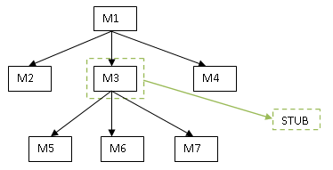

1. **Bottom-up approach**: in this the child module will be develop first and then related

parent module will be develop and integrated.

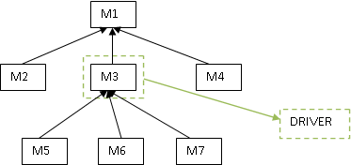

1. **Hybrid approach (or) sand-witch approach**: in this approach is mixed both top down and bottom up of approaches

|  |
| --- |
| M1 |

M3

M2 22222

M6

M5

M4

M8

M7

1. **Big-bang approach**: in this approach one will wait till all the modules are develop and

will integrate at a time at the end.

M3

M2

M1

M4

M5

M8

M7

M6

**Stub:** while integrating the modules in top down approach if at any one mandatory module is missing then that module is replaced with a temporary program none as **stub.**

**Driver:** while integrating the modules in bottom up approach if at all any one mandatory modules are missing than that module is replaced with a temporary program known as **driver**.

1. **System level testing:** in this stage the **block box test** engineers will conduct so many types

Of testing like **load testing** , **performance testing**, **stress testing**, **comparability testing**, **system integration testing** and etc.., One of them important is **system integration testing**.

**System integration testing:** in this type of testing one will do the actions at one module and

Check the reflections in all the related area of the application. May be in the same module or in the `different module reflection.

Ex: financial 🡪 sales 🡪 purchase 🡪 ware house 🡪 integration

1. **User acceptances level testing:** in this stage the **block box test engineers** will perform testing on the desired areas check the user in order to make him accept the application.

**Alpha, beta user acceptance testing**

**Alpha Testing** normally takes place in the development environment and is usually done by internal staff. Long before the product is even released to external testers or customers. Also potential user groups might conduct Alpha Tests, but the important thing here is that it takes place in the development environment.

Based on the feedback – collected from the alpha testers – development teams then fix certain issues and improve the usability of the product.

**Beta Testing**, also known as “field testing”, takes place in the customer’s environment and involves some extensive testing by a group of customers who use the system in their environment. These beta testers then provide feedback, which in turn leads to improvements of the product.

Alpha and Beta Testing are done before the software is released to all customers.

**Environment :( tiers)** it is a group of hardware component with some basic software which can hold presentation logic, business logic and database logic. (or)

Environment is defined as combination of presentation layer, business layer database layer.

Types of environment: there are 4 types of environments

1. Stand alone environment (or) single tier environment
2. Client server environment (or) two tier environment
3. Web environment (or) three tier environment
4. Distributed environment (or) n tire environment or multiple architecture

**Stand-alone environment:** this environment contains only one tier. The presentation layer, business layer, database layer will be present in the same tier whenever the application need to be used by a single user at a time then this environment suggested.

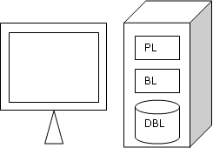

**Client server environment:** this environment contains two tier one is client mother one is for server. Whenever the application is need to be used by multiple users by sharing the common data and also we wants to access the application usually a single compound very fast then this environment can be very suggested.

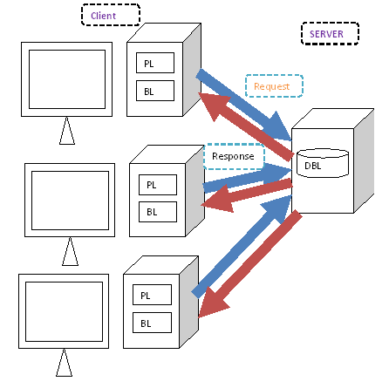

**Web environment:** in this environment 3 types will be there

1. Client ii. Application server iii. Data base server

Presentation layer will be present each and every client, business layer will be present in Application server. Whenever the application needs to be used all over the world by multiple users and the feature updating need to be done easily as well as the business logic need to be secure then this environment can be suggested.

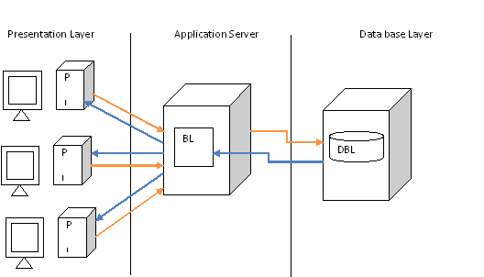

**Distributed environment:** this environment is similar to the web environment but the business logic is distributed among number of application server in order to distribute the load and increase the performance.

Whenever the application needs to be used all over the huge number of people then this environment can be suggested.

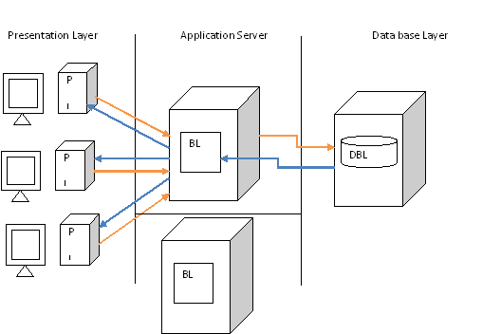

**SOFTWARE PROCESS DEVELOPMENT MODELS**

1. **Water fall Model:**

Advantages: It is a simple model project monitoring and maintenance very easy.

Draw backs: can’t accept the new requirement in the middle of project.

**UTR** Unit Test Requirement

**ITR** Integration Test Requirement

**MTR** Module Test requirement

**STR** System Test Requirement

**UATR** User Acceptance Test Requirement

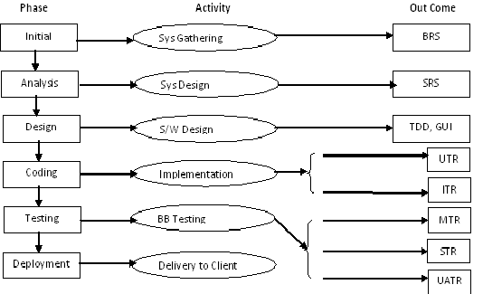

***2. Prototype model:***

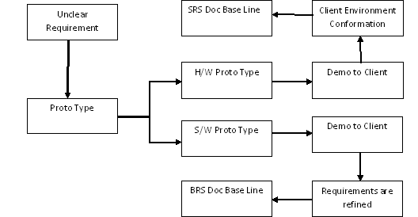

**Advantages:** whenever the customer is not clear with the requirements then this is the best suitable model.

**Drawbacks:**  it is a complete software development model

* Slightly time consuming model
* Company should bear the cost of prototype
* Customer may limit this requirement by striking to the prototype

**3.Evolutionary model*:***

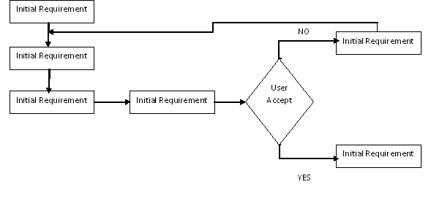

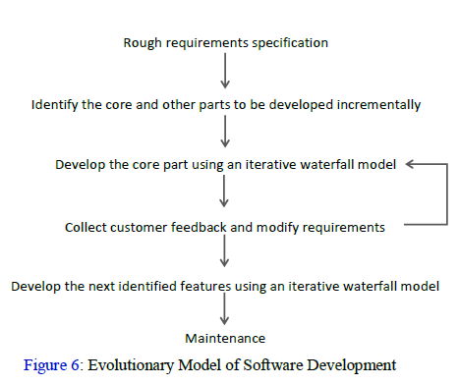

Whenever the customers are requirements then this is the best suitable model.

**Drawbacks**:

* time consuming model
* Costly model
* Deadlines can’t be properly defined
* No transferring
* Project monitoring & maintenance is big

**4. Spiral Model: *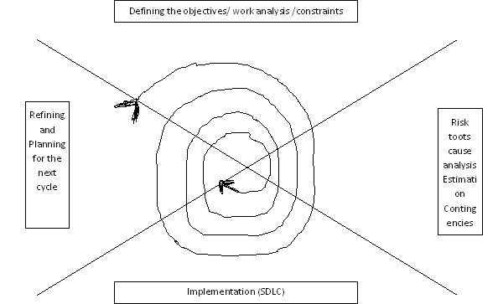***

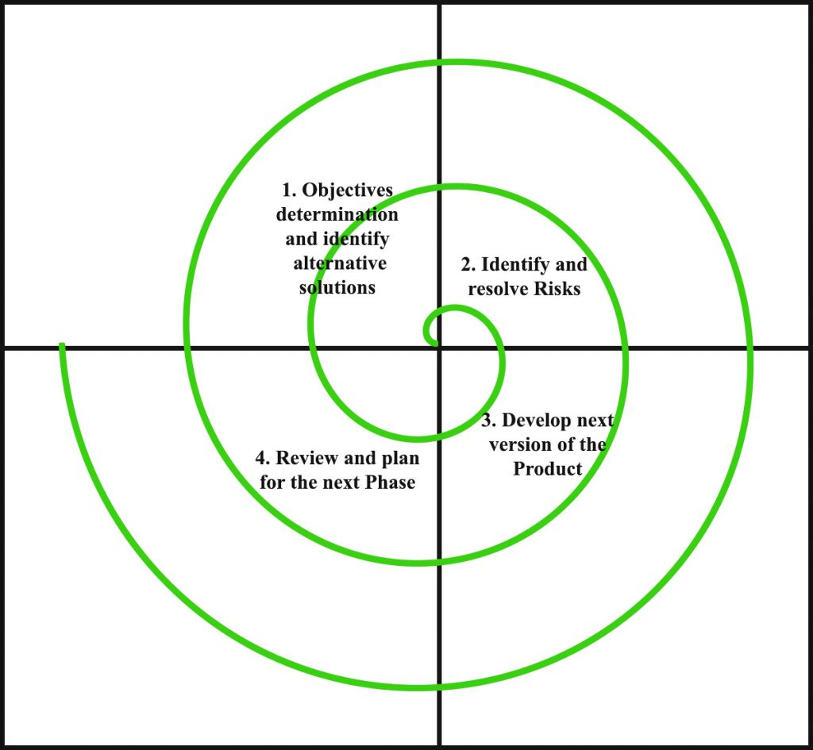

**Advantages**: whenever the project is highly risk based then it is the best suitable model

**Disadvantages**: 1. Time consuming model

2. Costly model

3. Risk root analysis is not easy model

**5. Fish Model:** Analysisdesign coding Delivery &

Requirement&HLDSystem testing

GatheringSRSSCD

LLD BRSBlock box Test s/w

Review SRS TDD white box testing changes review review testing

**Advantages:** as both verification & validation is done the outcome will be a quality product

**Draw backs**: time consuming model, Costly model

**6. V model:**

**Verification Validation**

**Initial & BRS 🡪 preparing project plan**

**Analysis SRS 🡪 preparing test plan**

**🡪 Req. phase testing**

**Design & TDD 🡪 Design phase testing**

**Coding SCD 🡪 unit &Integration testing (WBT)**

**Testing Software 🡪 system integration testing**

**Build 🡪 test management process**

**🡪 User acceptances testing**

**Delivery &maintains 🡪 port testing**

**🡪 Software efficiency**

Test software changes DRE= A

A+B

A = defects found by the testing team

B = defects raised by the customer

As both verification and validation and test management process is concentrated definitely the Outcomes quality product.

**Drawbacks**: i. time consuming model ii. Costly model

**Thick client**: if at all the client machine is having both the presentation logic & business logic than it has known has thick.

**Thin client**: if at all the client machine only the presentation logic than known as thin client.

**Verification** :( starting to ending) it is a process of checking conducted on each & every role in their organization. In order to conform weather they are doing their work according to the company guide lines or not.

**Validation** :( developed product) Validation is a process of checking conducted on the developed product are its related part in order to conform whether they are working expectations or not.

**Agile Methodology**

**Scrum**

**Scrum meetings**

1. **Daily Sprint (15 to 30 minutes daily call, impediments or blocker for everyone)**
2. **Sprint planning (pick the story from backlog and prioritize the story, assign the story points)**
3. **Sprint Review(completed story presents in front of customer, QA session)**
4. **Sprint Retrospective (What went well(congratulate to the Dev. /QA for achieving their task), what needs to be improved, action plan for what needs to be improved)**
5. **Sprint (how many days sprint)**

**Scrum board phases**

1. **To-do**
2. **Ready/Reopen**
3. **In Progress**
4. **Code Review**
5. **To Test**
6. **Testing**
7. **Acceptance**
8. **Master**
9. **On Hold**
10. **Done**

**Types of Testing:**

**Build acceptance testing (or) Build verification (or) Sanity Testing:**

It is a type of testing in which one will conduct over all testing on the released build in order to conform whether it is proper for conducting detailed testing(or) not.

To do the same one will check the following:

1. Whether the build can be properly installment into the environment or not
2. Whether one can navigate to all the pages and applications or not
3. Whether all the important objects available or not
4. Whether the required connections are properly established or not

In some company’s they will call this type of testing is smoke testing also. But in some company’s soon after the build is developed just before releasing the build developers will check whether the build proper or not that is known as smoke testing and once the build is released the test engineer will once again will check the same that is known as build acceptance testing & sanity testing.

**Regression testing: It** is a type of testing in which one will perform testing on the already tested functionality again and again usually you do it 2 scenarios.

* Whenever the defects are raised by the test engineer, after rectification the next build is released them the test engineer will check defect functionality as well as the related functionality once again.
* Whenever some new features are added to the application, next build is released then the test engineers will check all the related functionality of those new features once again in order to conform whether they are working fine or not.

Note: testing the new feature for the first time is new testing but not regression testing.

**Re-testing: It** is a type of testing in which one will perform testing on the same functionality again and again with multiple sets of data in order to come to a conclusion whether it working fine or not.

Note: re testing starts from the first build to last build

* Regression testing starts from second build and continue up to last build
* During regression also retesting will be done usually people call this as re and regression testing.

**œ testing: It** is a type of user acceptances testing conducted in the software company by their test engineers in the presence of the user just before delivery.

**β testing: It** is a type of user acceptance testing in which one will (either end users or third party testing experts) perform testing in the customers place just before actual implementation.

ex: look&feel, static, GUI

**Static testing: It** is types of testing in which one will perform testing on the application are its related factors without performing any actions.

Ex: GUI testing, document testing, code review etc.,

**Dynamic Testing: It** is a type of testing in which one will perform the application or its related factors by performing some actions.

Ex: functionality test.(Bus journey secendrabad or charminar guidelines)

**Installation testing: It** is a type of testing in which one will install the application into the environment by following the guide lines provided in the deployment document in order conform whether those guide lines are suitable for installing the application in to the environment or not.

Ex: installation process

**Compatibility testing :(** suitable**)** it is a type of testing in which one will install the application into the multiple environments prepare with different combination in order to conform whether the application is suitable to those environments or not.

Note: - Usually this type of testing is important for product rather than project.

**Monkey testing: It** is a type of testing in which one will perform abnormal action intentionally on the application in order to check the stability (standby) of application.

**Exploratory testing: It** is a type of testing in which one will (domain expert) test the application without having the knowledge the application just by exploring the application.

**Exploring:** having the basic knowledge of some concept doing something and knowing more about it is knowing as exploring.

**Usability testing: It** is a type of testing in which one will check the user friendliness of the application.

Ex; application open cursor wait starting point or not.

**End to end testing: It** is a type of testing in which one will perform testing on the end to end scenarios or the application.

**Port testing: It** is a type of testing in which one will install the application into the original customer environment and check it is suitable environment or not.

**Soak testing/ reliability testing: It** is a type of testing in which one will perform testing one the application continues for long period of time in order to check the stability of the application.

**Security testing: It** is a type of testing in which one will check whether application is properly protected or not. To do the same black box test engineers will implement following types of testing.

1. **Authentication/ Authorization testing: It** is a type of testing in which one will enter different combinations of user names and passwords and check whether only the authorized people are accessing people or not.
2. **Direct URL testing: It** is a type of testing in which one will enter the direct some URL secure pages and check whether they are able to access them are not.
3. **Fire wall in case testing/ User prevails testing: It** is a type of testing in which one will enter into the application as a one level of user and will try to access the application beyond its limits and check weather is able to access or not.

**Mutation Testing: It** is types of testing in which one will perform testing on application are its related factor by during some changes to them.

**Ad-hoc testing: It** is a type of testing in which one will (test engineer) perform testing on the application in their own style after understanding the requirements clearly. Usually this type of testing is after formal testing.

Ex: temporary random

**I18N Testing:** Internationalization testing is a non-functional testing technique. It is a process of designing a software application that can be adapted to various languages and regions without any changes.

Localization, internationalization and globalization are highly interrelated.

**Localization (l10n)**

Localization is the process of adapting a product or content to a specific locale or market. Localization is sometimes written as **l10n**, where 10 is the number of letters between l and n. The aim of localization is to give a product the look and feel of having been created specifically for a target market, no matter their language, culture, or location.

##### Internationalization (i18n)

Internationalization is a design process that ensures a product (usually a software application) can be adapted to various languages and regions without requiring engineering changes to the source code. Think of internationalization as readiness for localization. Internationalization is often written **i18n**, where 18 is the number of letters between i and n in the English word.

##### Globalization (g11n)

Globalization, in the context of the language industry, refers to a broad range of processes necessary to prepare and launch products and activities internationally. Sometimes written **g11n**, globalization is an all-encompassing concept which applies to activities such as multilingual communication, global-readiness of products and services, and processes and policies related to international trade, commerce, education, and more.

##### Example:

“Google Search Engine” has been taken as an example to explain localization, internationalization.

##### Localization (l10n):

Initially, Google developed the search engine in its own native language (English), culture and desired local “look and feel”. The following image shows the Google search engine designed for USA.

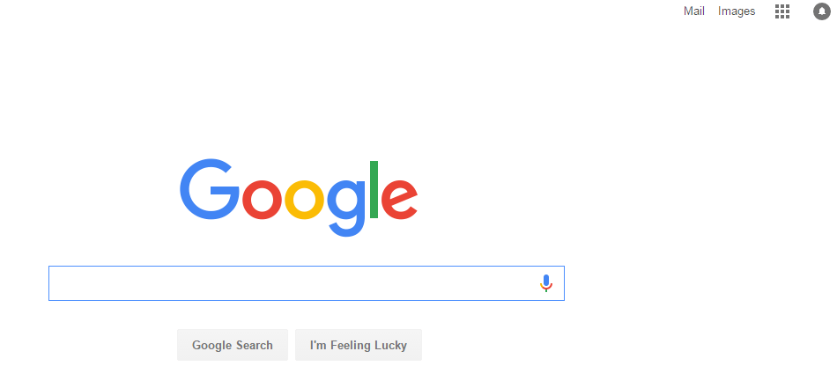

##### Internationalization (i18n):

As people are more comfortable in their native language, Google designed and developed its search products around the local geography, culture and language.  Google is now available in 123 languages and has been localized completely or partially for many countries.

The Google search engine for “India” has been developed in English along with 9 popular and widely spoken languages of the country. By selecting any one of the specific language, the entire design of the page will be changed based on the language selected.

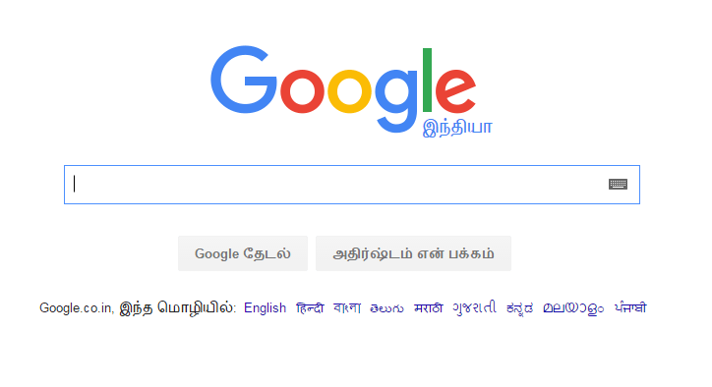

Thus in order to achieve the globalized standard and to make the software user-friendly, Internationalization testing has to be performed and it plays a major role.

**Need For Internationalization (i18n) Testing:**

If internationalization testing is not performed,

* It may have an adverse impact on product quality.
* The software may lack encoding of characters when converted to different languages.
* The software may crash or malfunction if the string is not supported in targeted languages.
* The font and font size may vary from language to language affecting the ‘look and feel’ of the application.
* It may not reach to intended audience.

**Internationalization (i18n) Testing at Front end:**

To perform internationalization testing, the testers have to focus on -Language, Culture, and Region, Dates and Important events.

* **First**testing should be done on a **user interface** such as alignment of texts, menus, and buttons, dialog boxes, images, and toolbar, prompt and alert messages.
* **Second** testing on **content localization**and **feature**should be performed on language specific properties files and on the region where the particular feature is enabled or disabled.
* **Third** **locale/culture awareness** testing should be performed on dates & number formats such as currencies, calendars, time, telephone number, zip code, etc.
* **Finally**testing on **file transfer**and **rendering**should be performed to make sure whether the file transfers are successful and to check whether the scripts supported to the website are correctly displayed.

The above steps, at a high level, covers front end testing.

**Internationalization (i18n) Testing at Back end:**

This process involves enabling the back end of a website to handle character encoding, form data submission, different languages and currencies and site search.

[Testing](https://www.dckap.com/ecommerce-qa-services.htm) at the back end requires an understanding of Content Management System (CMS) that is used to store, author and publish content on the websites. Thorough understanding of the database is highly important for testing at the back end.

Recent version of databases and Content Management System are already internationalized.

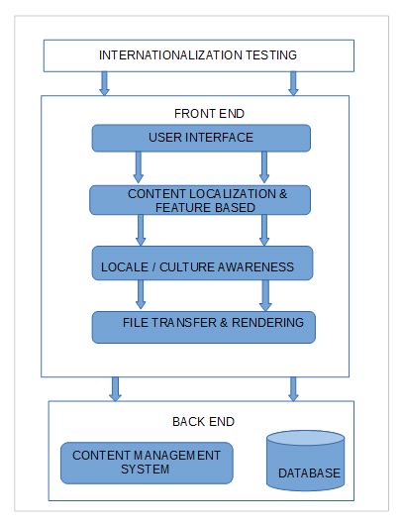

**Advantages of Internationalization (i18n) Testing:**

* Easier adaptation of software applications (or other content) to multiple locales
* Reduced time and cost for localization
* Single, internationalized source code for all versions of the product
* Simpler maintenance
* Improved quality and code architecture
* Reduced overall cost of ownership of the multiple versions of the product
* Adherence to international standards

Internationalization is a critical business process for any company producing multilingual products. It is important to consider the various markets a product will target and make the necessary adaptations early in product design and development.

**SOFTWARE TESTING LIFE CYCLE:**  these are 6 phases

1. Test planning
2. Test development
3. Test execution
4. Result analysis
5. Bug tracking
6. Reporting

**1. Test planning:**

**Plan:** plan is a strategic document which contains some information that describes how to perform a task in an effective efficient and optimized way.

**Optimization: It** is a process on utilizing the available resources to their level best and get in the maximum possible output.

**Test plan: It** is a strategic document which contains some information that describes how to perform testing on an application in an effective, efficient and optimized way.

Test lead will prepare the test plan.

**Index / contents of the test plan:**

1.0 Introduction

* 1. Objective

1.2 Reference document

2.0 Coverage of testing

2.1 Features to be tested

2.2 features not to be tested

3.0 Test strategy

3.1 Levels of testing

3.2 Types of testing

3.3 Test design Techniques

3.4 Configuration management

3.5 Test Metrics

3.6 Terminology

3.7 Automation plan

3.8 List of automated tool

4.0 Base criteria

4.1 Acceptance criteria

4.2 Suspension criteria

5.0 Test deliverables

6.0 Test environment

7.0 Resource planning

8.0 Scheduling

9.0 Staffing & training

10.0 Risks & contingency (spiral model)

11.0 Assumption

12.0 Approval information

**1.0** **Introduction:**

**1.1** **Objective**: the purpose of the document will be clearly described here in this section.

**1.2 Reference document:** the list of all the documents that are referred by the test level will be listed out here in this section.

Ex: system requirement specification project plan, SRS, Kick of meeting

**2.0 Coverage of testing**

**2.1** **Feature to be tested:** the list of the entire feature that are within the scope and need to be tested will be mentioned here in this section.

**2.2 Feature not to be tested:** the list of the entire feature that is not planned for testing will be mention here in this section.

Ex: 1. Out of scope features

2. Low risk features

3. Features that are plan to be in corporate feature

4. Feature that are skipped based on the time construction

**3.0 Test Strategy:** test strategy is a organization level tern which is common for all the project in the application.

Test plan is a project level term which is specific for particular project in the organization.

**3.1 Levels of testing:** the list of all the levels of testing that are maintained in that company will be listed out in this section.

**3.2 Types of testing:** the list of all the types of testing that are perform in that company will be listed out here in this section.

**3.3 Test design techniques:** the list of all the techniques used during developing the test cases in that company will be mentioned here in this company.

**Boundary value analysis + Equivalence class partition**

**Strictly concentrate on boundary**

**Password 8-15 chars**

**7 8 9 14 15 16 0 to 7, 8 to 15, 16 to 24**

**3.4** **Configuration Management:**

Configuration management determines clearly about the items that make up the software or system. These items include **source code, test scripts, third-party software, hardware, data, and both development and test documentation**. It ensures that these items are managed carefully, thoroughly and attentively during the entire project and product life cycle. It is sometimes referred to as **IT automation.**

The CM helps to improve performance, reliability, or maintainability; extend life; reduce cost; reduce risk and liability.

**Example**: Suppose your company creates an avionics system that includes an LCD screen from a third-party company. Over the time, the specific LCD screen becomes obsolete and you need to find a suitable replacement to continue your production. The CM policy would identify who in which organization is authorized to approve utilizing a different but compatible version of the original LCD screen.

### **3.4.1 Configuration Management Process**

The configuration management process is comprised of 5 disciplines that will establish a product’s baseline, and manage any changes over time.

* + - 1. **Planning and Management**: This guides the design of the product, who has what responsibilities, and includes which **tools and procedures to use**. It identifies **third-party requirements** and the audit and review process.
      2. **Identification**: Allows for setting baselines and identifying the configuration of assets and/or software.
      3. **Control**: Maintain control of configurations, change requests, and execution of changes to a system and its documentation.
      4. **Status Accounting**: The process of recording and reporting configuration item descriptions and changes from the baseline over the item’s life-cycle. If a problem arises, this allows for a quick determination of the baseline configuration and changes that have taken place over time.
      5. **Verification/Audit**: Be able to audit what you have implemented and maintain positive control of all managed product

**3.5 Test Metrics:** the list of all the metrics that are maintained in that company will be listed out clear in this section. (Noted in strategy document)

**3.6 Terminology:** the list of all the terms used in that company alone with meanings will be mention here in this section.

**3. 7Automation plan:** (regression testing presented automation) the list of all the areas that are plan for automation in that company will be listed out here in this section.

**3.8 List of automated tool**: the list of all the automated tools that are used in that company will be mentioned here in this section.

**4**.0 **Base criteria:**

**4.1 Acceptance criteria:** when to stop the testing on that application will be clearly mention in this section.

**4.2 Suspension criteria:** when to suspend the testing on suspend the build will be clearly mention here in this section.

If the suspension criteria are met during testing, the active test cycle will be **suspended** until the criteria are **resolved**. Example: If your team members report that there are **40%** of test cases failed, you should **suspend** testing until the development team fixes all the failed cases.

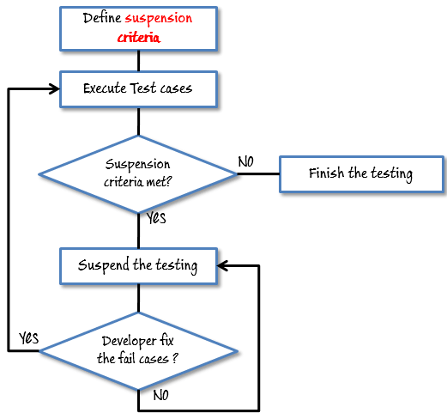

**5.0** **Test deliverable:** the list of all the documents that are to be prepared and delivery during the process will be mentioned here in this section.

**6.0** **Test environment**: the clear details of the environment that is about to be used for testing that application will be mentioned here in this section.

**7.0** **Resource planning**: who has to do what will be planned mentioned here in this section.

**8.0 Scheduling:** the starting date and ending date of each and every task will be plan and mentioned here in this section.

**9.0 Staff & training:** how much staff need to be recruited and what kind of training need to be provide will be mentioned here in this section.

**10.0** **Risk and contingency:** the list of all the potential risk that may occur during the process and corresponding solution plan will be mentioned here in this section.

**Ex**: i. employee may leave a organization middle of the project

ii. unable to deliver the project within the deadlines

iii. Customer may impose the dead lines

iv. unable to test all the features within the given time

Contingency:

* + - employee need to be maintain on bench
    - what not be tested should be plan in case of imposed dead line
    - Proper plan ensure
    - Priority base execution

**11.0 Assumption**: the list of all the assumption that needs to be assumption by a test engineer will be listed out here in this section.

**12.0 Approval information**: who has approved this document and when it is approved will be mention here this status.

**2. TEST DEVELOPMENT: (Business** analyst) (test case development)

Req document

HLI LLI

Screen shot& Snap shots

(High level information)

Use cases

**Use case**: It describes the functionality of certain feature of an application in terms of actors,

actions and responses.

Snap shot:

User name

Password

Connect to

Cancel

Clear

Login

**Functional requirements**:

* Login screen should contain user name, password, connect to fields, login, clear and cancel buttons.
* Connect to field is not a mandatory field but it should allow the user to select the database option if required
* Upon entering user name, password and clicking on login button the corresponding page must be displayed
* Upon entering some information into any of the field & click on clear button all the fields must be clear and the cursor must be available in the user name field.
* Upon clicking on cancel button login screen must be closed

**Special requirements or validations or Business rules:**

* Upon invoking the application login and clear buttons must be disabled
* Cancel button must be always enabled
* Upon entering some information into any of the field clear button must be enabled
* Upon entering some information into both username & password field’s login button must be enabled.
* Tabbing order must be user name, password, connect to, login, clear and cancel

**Use case template:**

* Name of the use case
* Brief description of the use case
* Actors involved
* Pre-conditions
* Post conditions
* Flow of events

**Use case document:**

**Name of the use case**: login

**Brief description of the use case:** this use case describes the functionality of all the features present in the login screen.

**Actions involved:** normal user & admin user special requirements

There are 2 types of special requirements

* Implicitly requirements
* Explicitly requirements

**Implicitly requirements**: the requirements that are analyzed by the business analyst & his team which will add some value to the application & will not affect only of the customer requirement.

**Explicit requirements**: the requirement that are explicitly given by the customer are known as explicit requirements

**Explicit requirements:**

* Upon invoking the application login and clear buttons must be disabled
* Cancel button must be always enabled
* Upon entering some information into any one of the field clear button must be enabled
* Upon entering some information into any of the field & click on clear button all the fields must be clear and the cursor must be available in user name field
* Upon click on cancel button login screen must be closed.

**Implicit requirements**:

* Upon invoking the application the cursor must available in the user name field
* Upon entering invalid user name& password and clicking on login button the

Following error message must be displayed

* “Invalid user name please try again”
* Upon entering valid username & invalid password & clicking on login button the following error message must be displayed
* “Invalid password please try again”
* Upon entering invalid user name & invalid password and clicking on login button the following error message must be displayed

Pre-conditions: Login screen must be available

Post conditions: either home page or admin page for valid users and error messages for invalid users.

**Flow of events Main flow:**

|  |  |
| --- | --- |
| Action | Response |
| Actor invokes the application | Application displays the login screen with the following fields: user name, password, connect to, login, clear & cancel |
| Actor enter valid user name, valid password and clicks on login button | Authenticates, applications displays either home page or admin page depending upon the actor entered. |
| Actor enters valid user name, valid password, selects a data base option & clicks on login button | Authenticates, application displays either home page or admin page depending upon action entered with the mentioned database connection |
| Actors enters invalid user name, valid password and clicks on login button | Go to alternative flow table 1 |
| Actor enter valid user name invalid password and clicks on login button | Go to alternative flow table 2 |
| Actor enters invalid user name, invalid password and clicks on login button | Go to alternative flow table 3 |
| Actor enters same information into any of fields and clicks on clear button | Go to alternative flow table 4 |
| Actor clicks on cancel button | Go to alternative flow table 5 |

Alternative flow table 1 (Invalid user name):

|  |  |
| --- | --- |
| Action | Response |
| Actors enters invalid user name, valid password and clicks on login button | Authenticates application displays the following error message  “invalid user name please try again” |

Alternative flow table 2 (Invalid password):

|  |  |
| --- | --- |
| Action | Response |
| Actors enters invalid user name, invalid password and clicks on login button | Authenticates application displays the following error message  “invalid password please try again” |

Alternative flow table 3 (Invalid user name &password):

|  |  |
| --- | --- |
| Action | Response |
| Actors enters invalid user name& password and clicks on login button | Authenticates application displays the following error message  “invalid user name &password please try again” |

Alternative flow table 4 (clear click):

|  |  |
| --- | --- |
| Action | Response |
| Actors enters same information into any of the fields and clicks on clear button | Application clears all the fields &makes the cursor available in the user name field. |

Alternative flow table 5 (cancel click):

|  |  |
| --- | --- |
| Action | Response |
| Actors clicks on the clicks on the cancel button | Login screen is closed |

The guide lines followed by a test engineers soon after the use case document is received:

1) Identify the module to which the use case belongs to

* Security module

2) Identify the functionality of use case with respect to the total functionality

* authentication

3) Identify the actors involved in the use case

* normal users, admin user

4) Identify the inputs required for testing

* valid & invalid user names and passwords

5) Identify whether the use case is linked with any of the use cases

* it is linked with home page &admin page use cases

6) Identify the pre-condition

* login screen must be available

7) Identify the post condition

* either home page or admin page for valid for user and error message for invalid

Users

8) Identify the function point & prepare the function point document

9) Understand the main flow of the application

10) Understand the alternative flow of the application

11) Understand the special requirements

12) Document the test case for the main flow

13) Document the test cases for alternative flow

14) Document the test cases for special requirements

15) Prepare the cross reference matrix or trace ability matrix.

**Functional point**:

The point where the user performs some action in the application can be considered as functional point.

Testing process related document:

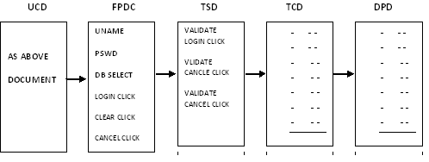

**Traceability matrix:**

Traceability matrix is a document which contains table of information used for traced back reference in any kind of confusion or questionable situation

**Complete Traceability matrix (CTM):**

|  |  |  |  |  |
| --- | --- | --- | --- | --- |
| UC_ID | FP_ID | TS_ID | TC_ID | DP_ID |
| 24.1  32.0  82.4  100.0 | 8  24  52  70 | 4  8  v28  35 | 38  52  100  250 | 1  2  3  4 |

Requirement traceability matrix:

|  |  |
| --- | --- |
| T CDID | Req ID |
| 1 | 1.0 |
| 2 | 1.0 |
| 3 | 1.1 |
| 4 | 1.1 |
| 5 | 1.2 |

Defect traceability matrix:

Defect ID

|  |  |
| --- | --- |
| D Id | Tc Id |
| 1 | 38 |
| 2 | 34 |
| 3 | 52 |
| 4 | 70 |
| 5 | 90 |

**Types of test cases:**

Test cases are broadly divided into 3 types

1. GUI Test cases
2. Functional Test cases
3. Non-functional test cases

Functional test cases are further divided into 2 types

1. Positive test cases
2. Negative test cases

**Guidelines for writing the GUI test cases:-**

* Check for the availability of all objects.
* Check for the consistency of the objects.
* Check for the alignment of objects in case of customer requirement only.
* Check for the spellings and grammar.
* Apart from the above guidelines any other idea we get with which we can test something in the application just by look and feel without doing any action, and then all those ideas also can be considered as GUI test cases.

**Guidelines for writing the positive test cases:-**

* A test engineer should have positive mind set.
* He should consider the positive flow of the application.
* He should use only valid inputs from the point of functionality

**Guideline for writing negative test cases:-**

* Test engineer should have negative mend set.
* He should consider the negative flow of application.
* He should use at least one invalid input for each set of data.

|  |  |
| --- | --- |
| Project name |  |
| Module |  |
| Author |  |

**Test case Template:**

|  |  |  |  |  |  |  |  |  |  |  |
| --- | --- | --- | --- | --- | --- | --- | --- | --- | --- | --- |
| **Req._ID** | **TC_ID** | **Category** | **Prerequisite** | **Description/test steps** | **Expected Value** | **Test Data** | **Actual Value** | **Result** | **Build No** | **Priority** |
|  |  |  |  |  |  |  |  |  |  |  |

**3. Test Execution:**

In this phase the test engineer will do the following

1. They will perform the action as it is described in the description column
2. They will observe the actual behavior of the application.
3. They will write the observed value in the actual value column.

**4. Result Analysis**: In this phase the test engineer will compare the expected value with the actual value if both are matching they will decide the result is pass otherwise fail.

Note: If at all the test case is not executed because of any reason then the test engineer will keep block in the result column of test case template.

**5. Bug tracking**: Bug tracking is a process of identifying, isolating and managing the defects.

Defect profile Template:

Test case id: The test case id based on which defect is found will be mentioned here in this section.

Defect id:

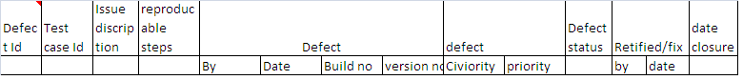

The sequence of defect numbers will be mentioned here in this section.

**Issue description:**

What exactly the defect is will be clearly described in this section.

**Re-producible steps:**

The list of a all the steps followed by the test engineer to identify the defects will be listed out here in this section

**Defected by:**

The name of the test engineer who has identified will be mentioned here in this section.

**Detected date:**

The date on which the defect is identified will be mentioned here in this section.

**Detected build no:**

The build number in which the defect is identified will be mentioned here in this section.

**Detected version:** (change management team given version no)

The version number in which defect is identified will be mentioned here in this section.

**Severity**: Severity describes the seriousness of the defect

Severity is classified into 4 types

1. Fatal
2. Major
3. Minor
4. Suggestions

**Fatal defects**: If at all the problems are related to the navigational blocks or un-availability of main functionality then such type of defects are treated as fatal defects.

Ex:

Value 1

Value 2

Value 3

Value 1

Value 2

Value 3

**Major defects:**

If at all the problems are related to working of the main functionality then such type of defects are treated as major defects

Value 1

Value 2

Value3

**Minor defects**:

If at all the problems are related to the look and feel of the application then such type of problems is treated as minor defects.

**Suggestions:**

If at all the problems are related to the value of the application (user friendliness) such type of problems are treated as suggestions.

**$**

Invalid values please try again

Please try again

Invalid entry please enter the value

**Priority**: Priority describes the sequence in which the defects need to be rectified. Priority classified into 4 types

1. Blocker
2. Critical
3. Major
4. Minor

Usually fatal defects critical priority, major defects will be given high priority, minor defects will be given medium priority and suggestions will be given as low priority.

**But depending upon the situation priority will be changed by the development lead.** Sometimes highest severity defects will be given low priority vice versa….

Case 1: least severity highest priority whenever the customer visits all the look and feel defects given highest priority. Case 2: highest severity least priority

Whenever some part of module or application released to testing department as it is under construction the tester will usually raise it is fatal defect but the development lead treat it as least priority.

**High priority and low severity**

1. **Logo of organization in home page is wrongly posted.**
2. **2 % extra interest on festival time after certain time still the message will be displayed on their portal.**

**High priority and high severity**

1. **In ATM machine same bank ATM (Free) and other bank ATM having same charges per transaction.**
2. **Valid credentials are not working properly.**

**Low Severity and low priority**

1. **Spelling mistake inside the application blogs or messages.**

**Example icici (iccic)**

**Error – white box tester/ developer – while development the developer execute their code.**

Hold

**Bug/Defect life cycle: black box tester**

As per design

No

Rejected

Open

Is it really a defect?

Is it really a defect

Yes

Development

Testing

Rectification

Application

Fixed

Yes No

If defect

New

Stop the testing

Re-open

Is defect really fixed ?

No yes

Closed

New :

Whenever the defect is newly identified for the first time then by the tester he will set the status as new

Open :

Whenever the developer accepts the defect then he will set the status as open.

Differed:

Whenever the developer accepts the defect and wants to rectify it later stages then he will set the status as differed.

Fixed: Once the defect is rectified then the developer will set the status as fixed or rectified

Re open and closed:-

Once the next build is released the tester will check whether the defect is really rectified then he will set the status as closed otherwise re open.

Hold :

Whenever the developer is confuse to accept or reject then he will set the status as hold

When the defect is in hold status they will be a meeting on the defect and if it is decided as a defect then the developer s well set the status as \open otherwise tester will be closed

Rejected:

Whenever the developer feels that is not at all defect then they will set the status as rejected.

Whenever the defect is rejected then the test engineer will once again check it if at all they also feel it is not a defect then they will set the status as close or re-opened

As per design :( rare case)

Whenever developer feels the testers are not aware of latest requirement then they will set the status as per design.

Whenever the defect is as per design the tester swill once again check it by going through the latest requirements if at all they also feel it is as per design then they will set the status as closed otherwise re opened.

**6. Classical bug reporting process**:

Test leader Develop leader

mail

**Drawbacks**: i. time consuming ii. Redundancy

iii. No transparency iv. No security

**Common repository oriented bug tracking process**:

This is not send mail it is only security purpose, only store one (server) box and take only authority developer.

Test leader Develop leader

CR

tl1 tl2 tl3 D1 D2 D3

**Draw backs**: i. time consuming ii. Redundancy iii. No security

**Bug tracking tool oriented bug reporting process:** every software user used some tools

**Ex**: I tractor, He tractor it is a simple software. It is can’t access people it is only used for bug tracking. In house tools are using only house purpose.

This is the latest process all company’s is use now a days.

Team leader CR Develop leader

BTT

1 - - - 2 - - - - - - - 3

1

**Draw backs:** i. no security ii. No consuming iii. Full transaction

**Note**: quality center is a bug tracking tool, Bug tracking tool is a software application which can be access only by the authorize users they onetime do all the activities comfortably relative to bug tracking and reporting.

**Test closure activity:** Test leader will prepare one test summery; this is the final activity for the testing process usually done by the test summery report, which usually contains following information

* No. of cycles(builds) of execution
* Duration of each cycle
* No. of defects found in the each cycle
* No. of test cases executed in each cycle and etc…,